Charles Tyrwhitt: The Three BEs
Bringing employer values into recruitment marketing
Client | Charles Tyrwhitt
Sector | Retail & Fashion
Delivered through | Gaia
Scope | Campaign messaging, asset selection, creative copy, social captions, Google ad copy
Campaign | The Three BEs — Management Roles, New Store Opening, Portsmouth
Result | All advertised roles filled in under a month
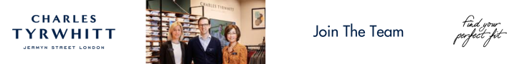
Charles Tyrwhitt recruitment banner ad

The Challenge
Charles Tyrwhitt was opening a new store in Portsmouth and needed to fill management roles fast. But this wasn't just about getting applications in. They wanted candidates who understood the culture and could see themselves as part of it before they even applied. So the brief was really two things at once: fill the roles, and show people what it's like to work there.

The Approach
I built the campaign around three themes, developed from the client brief: BE The Boss, BE The Customer, and BE The Best. Each one gave candidates a different lens on the job and the business.
BE The Boss was about ownership and initiative:
"At Charles Tyrwhitt, we own every success, drive results with energy, and celebrate both team and partner achievements. We believe in empowering our people to make things happen. We're proud to bring that spirit to Portsmouth as we continue growing our team in the city."
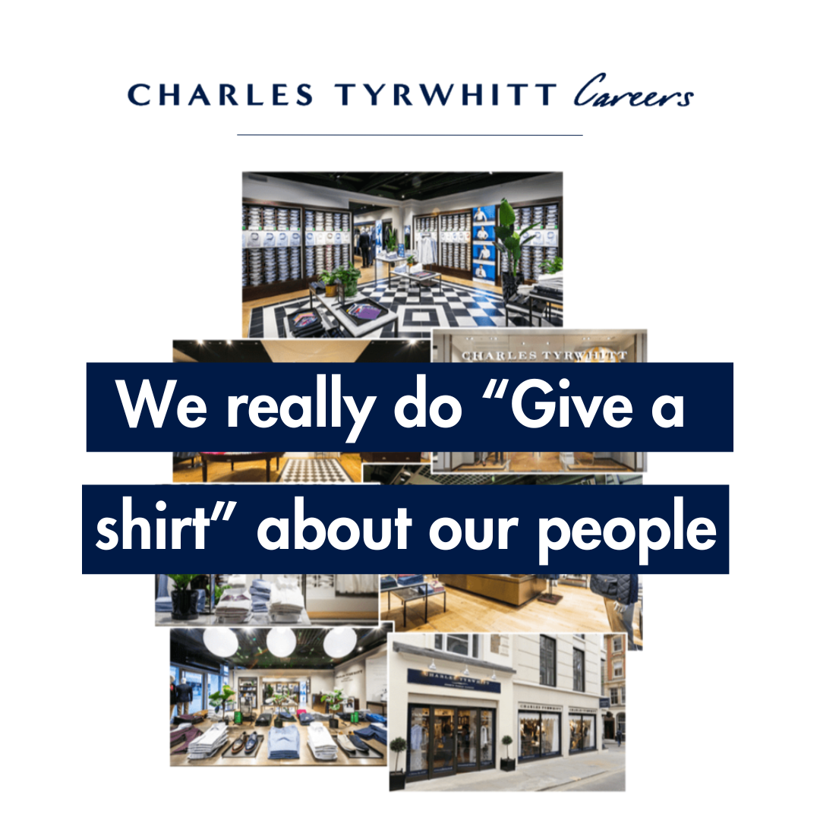
BE The Boss touchpoint creative
BE The Customer focused on the service mindset:
"At Charles Tyrwhitt, we put customers first in everything we do. We're looking for individuals in Portsmouth who are passionate about delivering exceptional service and ensuring every customer has a great experience."
BE The Best spoke to growth and individuality:
"We want people who strive to be their best every day. At Charles Tyrwhitt, we celebrate individuality and development. If you're driven to grow and be proud of who you are, this is the place for you."
Each theme carried through to a "why join us" section covering the practical stuff too: competitive salary and holiday allowance, 50% staff discount, health and wellbeing benefits, training and development.
I wrote the copy for every touchpoint and adapted it across the full channel mix:
- 3 x ad posts on Facebook and Instagram
- 1 x ad post across TikTok, Snapchat and X
- 1 x wide skyscraper Google ad
- 1 x leaderboard Google ad
- Copy and captions for a vertical video
The wide skyscraper ad needed the whole message boiled down to a handful of lines: “Legacy built on excellence. BE A Tyrwhitteer!” The leaderboard ad had even less room, so I kept it to the campaign name and a clear call to action: “BE The Boss, BE The Customer, BE The Best. Join us now.”
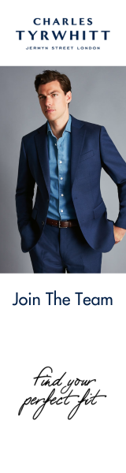
Wide skyscraper Google ad
Across every format, the challenge was the same: keep Charles Tyrwhitt's voice consistent whether I had a full paragraph to work with or a single line, and make sure each touchpoint still felt like part of one story rather than six separate ads.
I selected the supporting imagery alongside the copy, then worked with Gaia's design team to bring everything together into the finished static and video creative, checking back against the brief throughout.

The Result
All advertised management roles were filled in under a month.
Every touchpoint went live across social and paid search, with the same three themes carried consistently through every format, from a full social caption down to a two-line banner ad. This campaign is one example of the ongoing recruitment and employer-branding work I delivered for Charles Tyrwhitt through Gaia, work that also contributed to Gaia's Best Recruitment Marketing Award.

