Tesla: Build the Future
A pitch campaign for Tesla's UK recruitment launch
Client | Tesla
Sector | Automotive, Advanced Manufacturing
Delivered through | Gaia (pitch)
Scope | Campaign concept, creative copy, touchpoint messaging across video and social
Campaign | “Build the Future”, pitched for Tesla's UK recruitment launch
Outcome | Pitch won strong client praise; deal stalled on commercial terms, not on the work itself

The Challenge
Tesla was preparing to start recruiting in the UK and Gaia was pitching to win the business. This meant writing a campaign with no live brief feedback loop and no existing relationship to draw on, built to convince a company known for its own strong brand identity that an external agency could speak in its voice convincingly, at pitch stage, with no client input yet.
The roles in question were specialist manufacturing positions, tool and die specialists among them, for a UK audience that needed both a technical and emotional reason to consider joining a company still establishing its UK manufacturing presence.

My Contribution
I developed the concept and copy for “Build the Future,” a campaign built around the idea of skilled tradespeople shaping something genuinely new, rather than the usual generic industrial recruitment pitch.
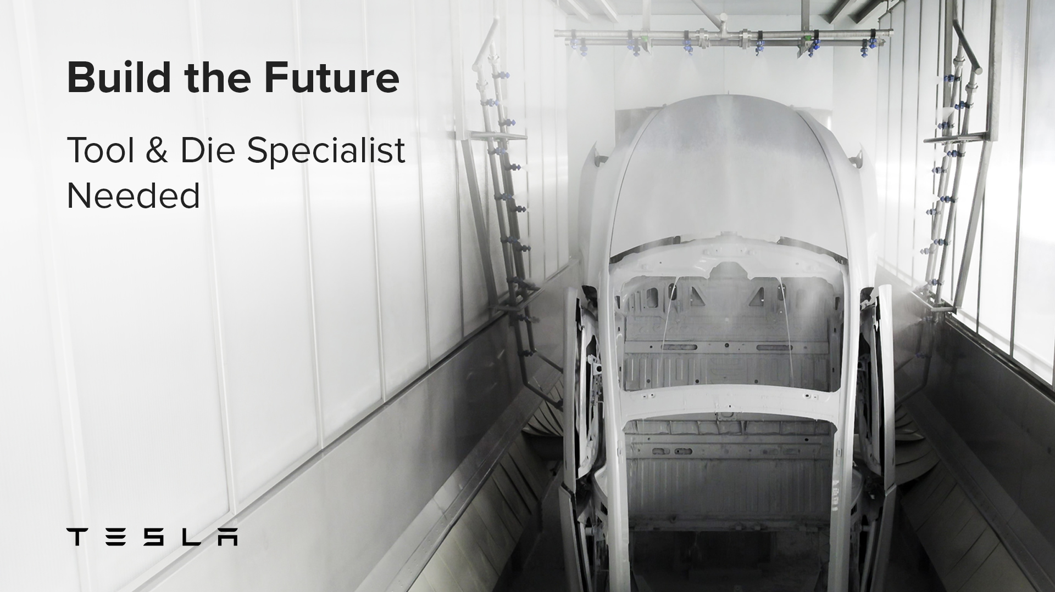
“Build the Future”, Tool & Die Specialist touchpoint
The lead message paired a striking manufacturing floor image with a direct, confident headline:
“Build the Future. Tool & Die Specialist Needed.”
A second thread leaned further into Tesla's own language around innovation, positioning the roles as part of something bigger than a single job:
“Engineering the Future of Manufacturing. Skilled Tool & Die Specialists Needed.”
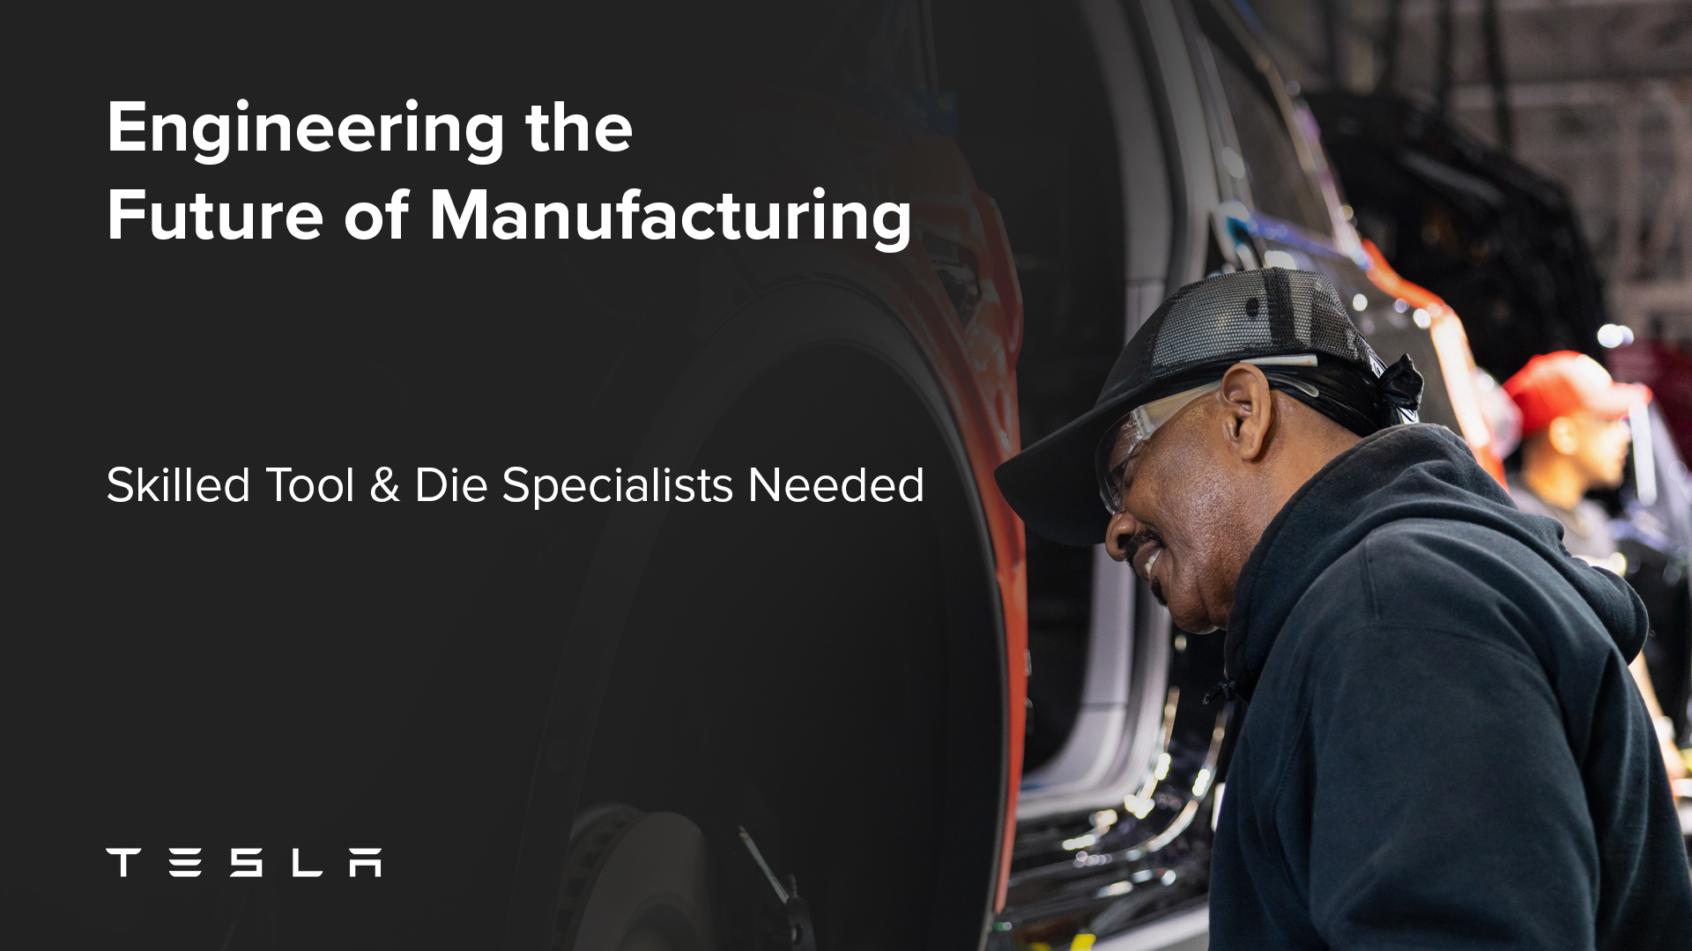
“Engineering the Future of Manufacturing” touchpoint
I wrote the copy across multiple formats and aspect ratios, landscape and square stills plus video, so the same message could run consistently across social feeds and video placements without losing impact in any one format.
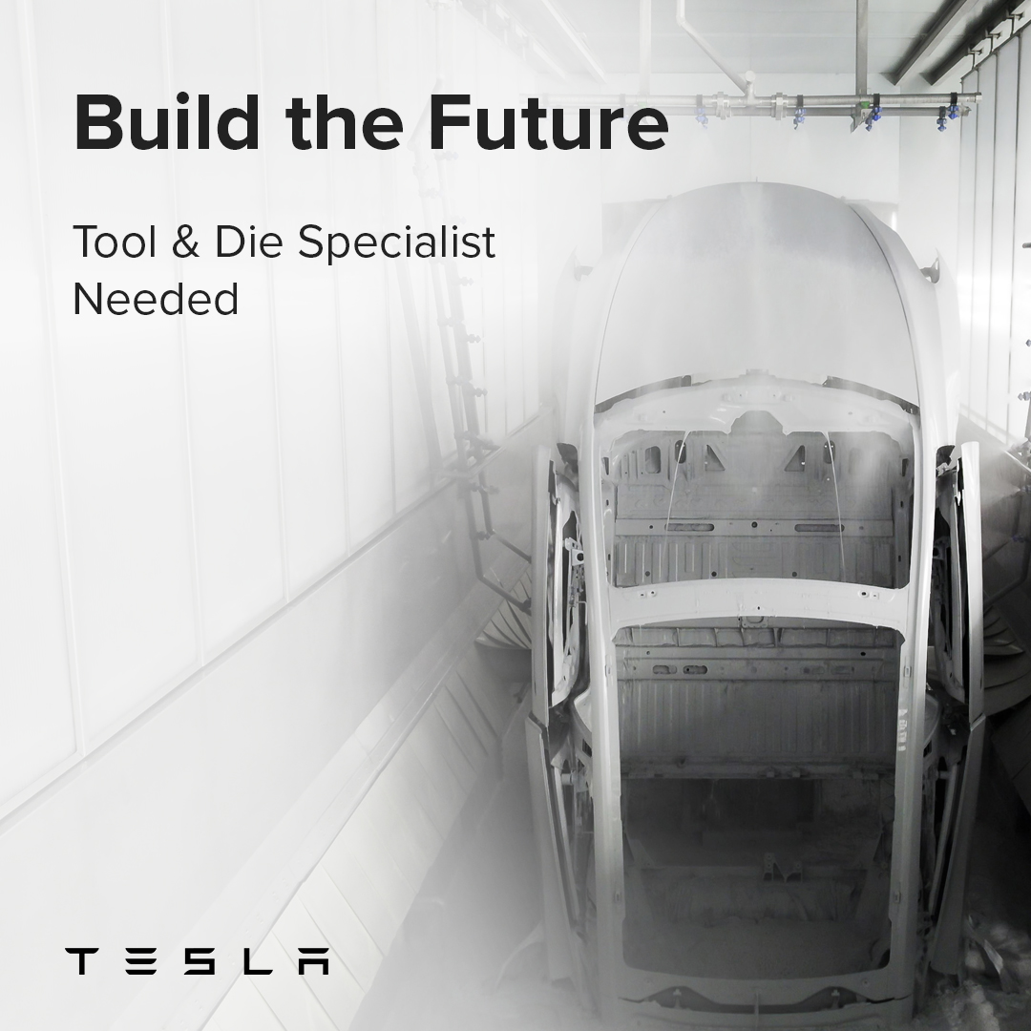
Square-format version for social placements
Every touchpoint had to do two jobs in the pitch: sell the specific roles clearly enough that a hiring team could see it working in practice, and demonstrate that the agency could capture Tesla's brand voice convincingly enough to be trusted with it.

The Outcome
The pitch landed. Tesla's team responded with genuine surprise, asking how the creative had been pulled off, and how it had been done in such a short amount of time. They were keen to move forward. In the end, the deal stalled on commercial terms rather than on the quality of the work.
Matthew Duckham, Gaia's sales lead on the pitch, put it this way:
“It made my job so much easier, being able to showcase creative work like that. It really showed how important cross-departmental collaboration between sales and marketing is.” — Matthew Duckham, former Sales Lead, Gaia
Even without a signed contract, this remains one of the clearest examples of the work speaking for itself. Winning that reaction from a brand as protective of its identity as Tesla, entirely on the strength of a pitch with no prior brief conversations, says as much about the quality of the creative as any delivered campaign result would.

